Discovery Top Falcons for August
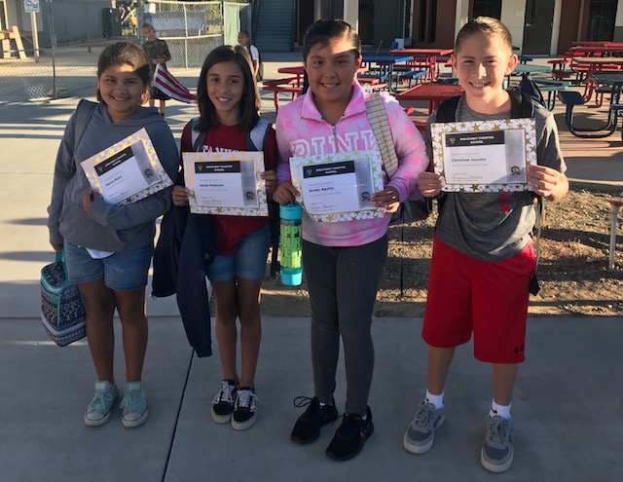
(Starting from left)
Peregrine: Alyssa Muniz, Amur: Alivia Peterson, Saker: Anahy Aguilar, Kestrel: Christian Jacobo.

Special Shout Out to Christian Jacobo for earning Overall Top Nest Earner with 16,695 points for the month of August!
DCS Survival Tip #3: School Planner
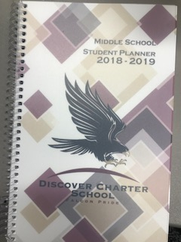
All students have a Discovery Falcon planner that was given to them at the beginning of the school year.

What should be written in the planner?
Daily homework assignments, project checkpoints and completion due dates, upcoming quiz/test/midterms/finals and concepts that need to be studied that night to prepare for the next day.

Are agendas being checked by teachers?
Yes, agendas are checked and are also graded by the two math teachers for completion, upkeep and accuracy.
How does my child know what the homework is?
Each teacher has a system in place for their students. For example, in Ms T’s room all homework is clearly written down in the box on her whiteboard and that’s the designated area where kids know to look everyday.

Examples of DCS Student Agenda Organization in Action:
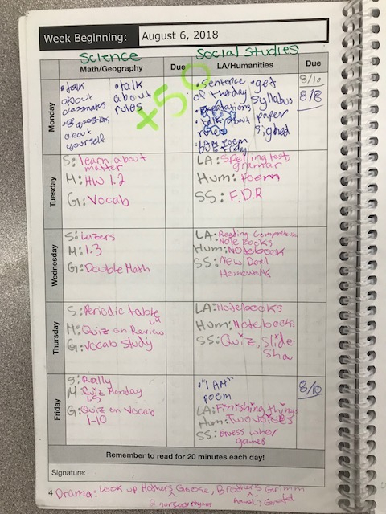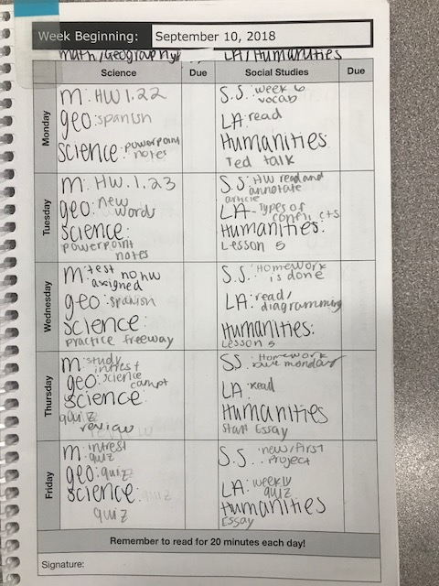

SWO season is upon us!
→ What is a SWO? SWO stands for School Wide Outcomes
Discovery has four main beliefs that our SWO’s are built upon that we want our students to leave Discovery encompassing:
1. Personal Awareness: knowing oneself and understanding what makes them unique
2. Cooperative Collaboration: the ability to learn how to work together with others and share ideas to create something amazing as an end product
3. Lifelong Learner: having a sense of wonderment and eagerness to take initiative to explore the world of possibilities and learn new things.
4. Dedicated DCS Student: taking pride in their school and education- realizing that they are in the driver's seat and it’s within them to lay the foundation to accomplish their personal goals and ambitions.

Each of these four SWO’s has two components: A corresponding project and a scrapbook section. SWO’s will be introduced one at a time by the 2 subject teachers in charge.

Scrapbook: Students will use their scrapbook that will last them from 5th grade through 8th grade SWO’s.

The first piece is the Cover Page, which is due Friday, September 28th to your child’s homeroom teacher. Rubrics and guidelines were passed out Wednesday and Thursday of this week. A letter about SWO’s was also sent home today (Friday) with a breakdown of due dates of projects and which teachers are in charge of which section.

Spotlight on ⅚ Classrooms

-Math Department-

Ms. T’s Classes:
Varsity: We have been working on perfecting short division and our divisibility rules. We had a special guest, Mrs. Stewart, who expanded our knowledge and taught us the rule of 4. We had a quiz on whole number operations and students received them back this week to take home.
Scholastic: Our class finished up adding and subtracting fractions with common and unlike denominators. We started multiplying fractions on Thursday and learned how to cross cancel to make our calculations quicker and easier! Scholastic received their latest quizzes back today (Friday) to take home.
Honors: We have been working hard this week learning about real world math. Please ask your child about principal, interest rates over time, loans and savings accounts. We have had great conversations about these topics, which even led into a discussion about credit cards and why it is important to pay off debts so you don’t accrue interest or have penalty fines.

Mrs. Zuniga’s Classes:
Varsity: This week we focused on word problems, from one step to multi-step word problems. The students are still perfecting their short division and divisibility rules. The class will be taking a quiz on whole number operations Wednesday.
Scholastic: This week the students have finished adding and subtracting fractions. They got their latest quiz returned today, to take home and raised their class average from the last quiz! We will begin multiplying fractions today and continue to increase our knowledge of fractions.
Honors: This week the students finished their fraction portion of Unit 1 and did very well on their fraction test which they received back on Thursday to take home. The students began learning about decimals and have started to add and subtract decimals as of Wednesday. They are looking forward to continuing their hard work and have high expectations.

-Discovery Physical Education-

For the past three weeks, all PE classes have been learning different skills, offensive/defensive strategies, etiquette, and rules, pertaining to their units. In Coach Easterday’s class students have been learning how to play Lacrosse. In Coach Penirian’s, students have been learning how to play Rookie Rugby. In Coach Williams’s they have been learning how to play soccer.
Today wraps up the final day of their first unit and next week they will be rotating to next units. Coach Easterday’s class will be in Rookie Rugby, Coach Penirian’s class will be in soccer, and Coach Williams’s class will be in Lacrosse.
Pictures of football Friday Hosted By PE Coaches (9-7-18) 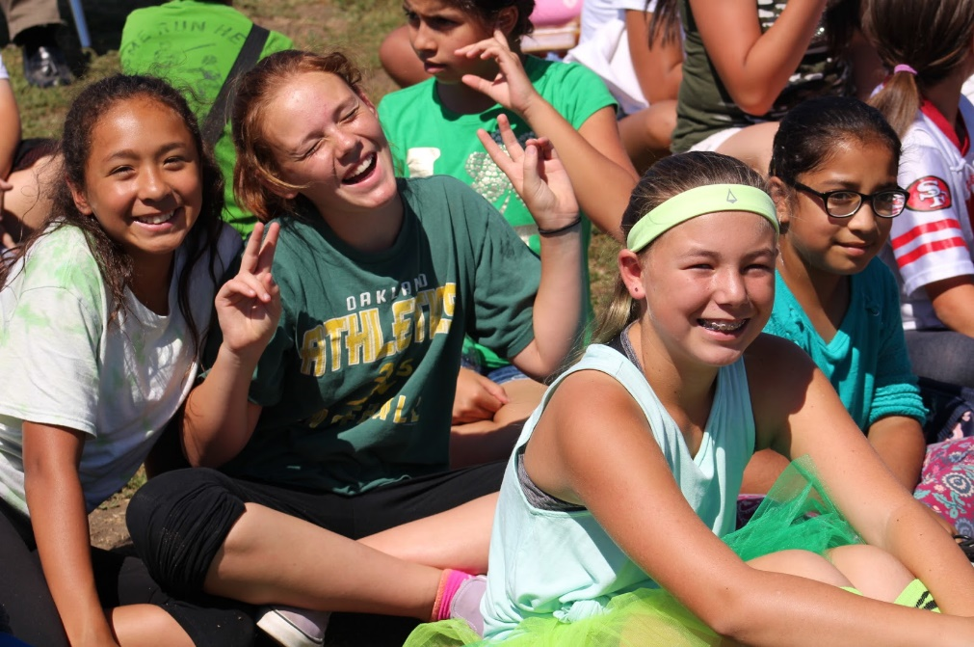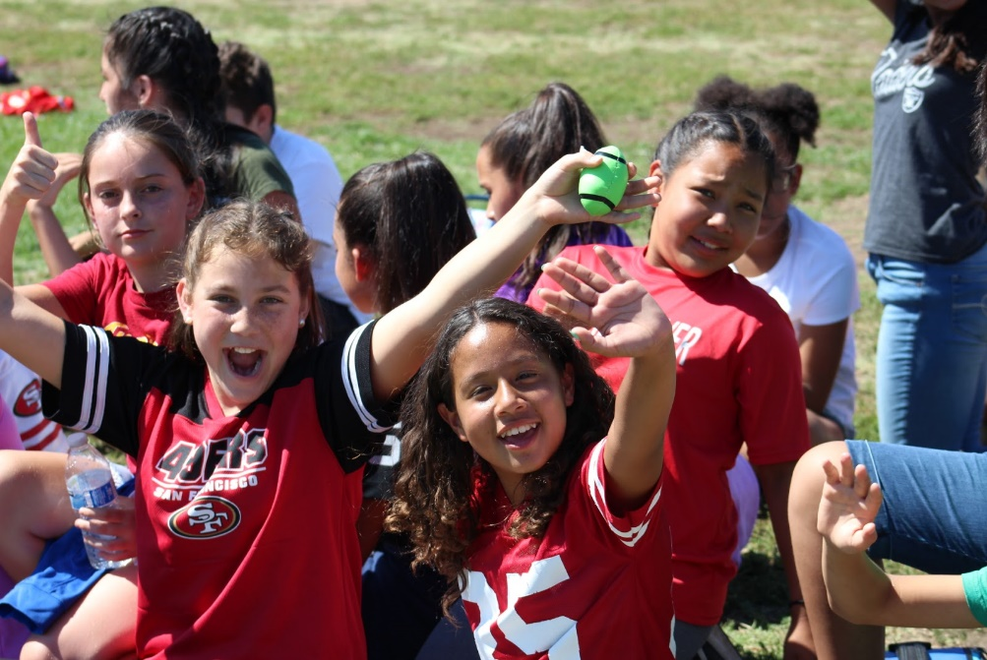
More pictures from events can be found on Ms T’s website:
https://dcsmathwithmst.weebly.com/

